The Partnership for Excellence
829 Bethel Road, #212
Columbus, OH 43214
www.thepartnershipforexcellence.org

2023 Quest for Success - Call for Presentations

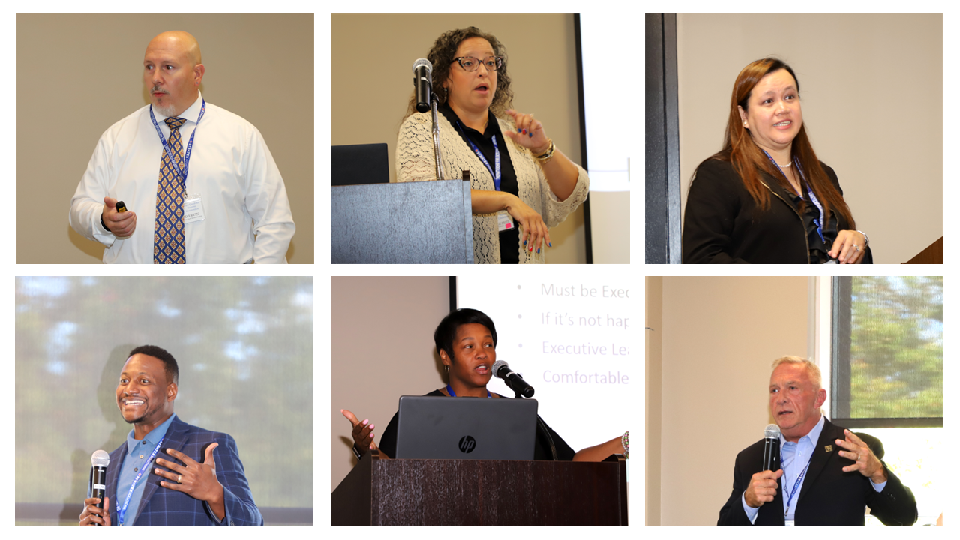
The Partnership for Excellence – 2023 Quest for Success Conference
September 12, 2023 at The Ohio State University, Columbus, Ohio
Celebrating 25 Years of Performance Excellence!

The Partnership for Excellence is seeking qualified speakers to present at our 2023 Quest for Success Conference on September 12, 2023. The theme of the conference is Pursuing Performance Excellence: Navigating the Road to Improvement.

Individuals volunteering to speak at the 2023 Quest for Success Conference will submit the following completed Request For Proposal (RFP) for consideration.

Proposals to be submitted to TPE no later than April 30, 2023.

Speakers are responsible for their own travel expenses. Sessions on the day of presentation are complimentary. Fees apply to other conference activities. When registration opens in June, all speakers must register for the conference at Quest for Success Conference | The Partnership for Excellence

Questions regarding this RFP can be directed to Margot Hoffman, President & CEO at 614-425-7157.

INSTRUCTIONS FOR COMPLETING THE RFP:
1. Complete the Administrative Section of the RFP (see next page)
2. Submission to include:
- Photo(s) and short bio(s) of presenter(s)
- Presentation title and summary of proposed presentation (one paragraph)
4. Send the completed RFP (Administrative Section and Submission) to margot.hoffman@partnershipohio.org by April 30, 2023

REQUEST FOR PROPOSAL - ADMINISTRATIVE SECTION

Contact information

Lead Presenter:

Name __________________________________________________________________

Title ______________________________ Organization __________________________

Address_________________________________________________________________

City ____________________________State_______ Zip Code____________________

Phone Number _____________________ E-Mail Address ________________________

Co-Presenter: (if applicable)

Name __________________________________________________________________

Title ______________________________ Organization __________________________

Address_________________________________________________________________

City ____________________________State_______ Zip Code____________________

Phone Number _____________________ E-Mail Address ________________________

Consent to release material information and likeness:

If selected to speak at the 2023 TPE Quest for Success conference, I authorize The Partnership for Excellence to use information provided here and materials submitted in conjunction with this RFP to promote the 2023 conference (check below if you agree to this statement):

_______ Agreed to by Presenter _______ Agreed to by Co-Presenter(s) if applicable

Would you be interested in leading a future TPE webinar? _______ Yes _______ No

Signed ______________________________________________ Date ___________________

